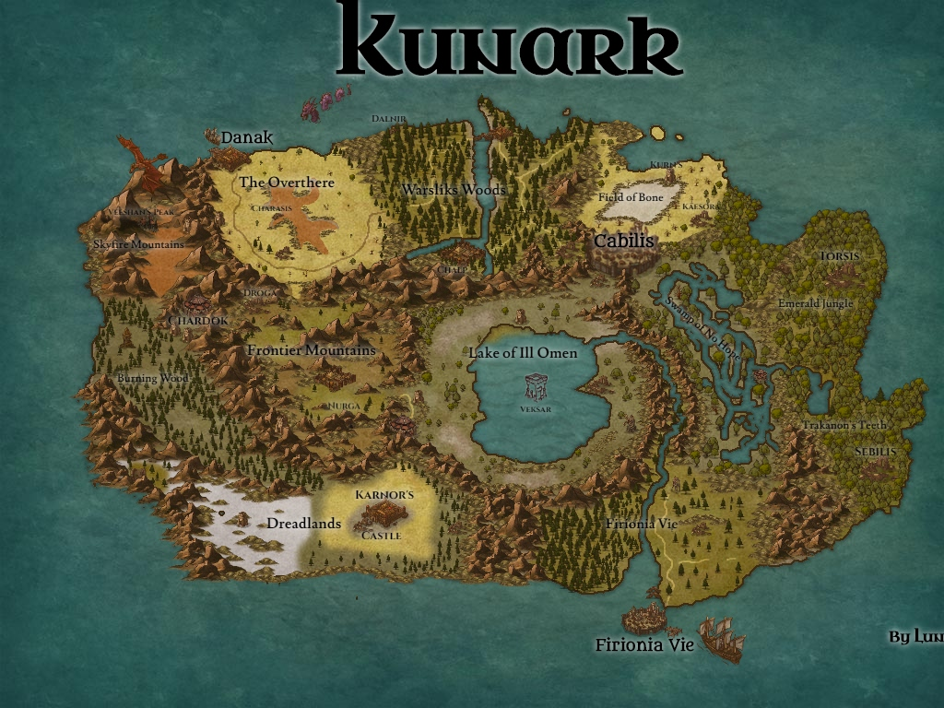

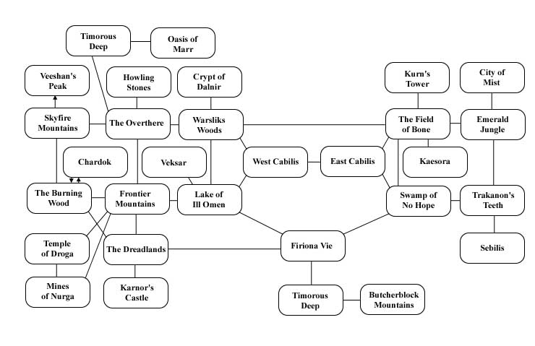

**Firiona Vie**

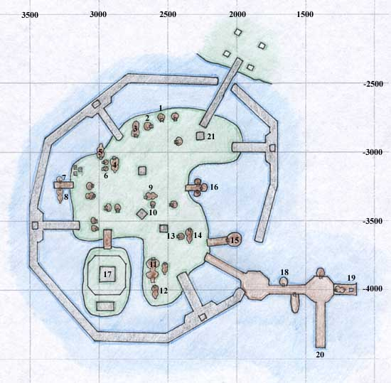

* 1. Merchant selling Food, Water, Cookbooks, and Mixing Bowl
* 2. Merchants selling Bags and Boxes
* 3. Merchants selling Weapons, Medium Plate and Chain Armor, Oven and Forge outside
* 4. Tunnel inside that leads to west side of the bay
* 5. Merchants selling [Bard](https://wiki.project1999.com/Bard) Songs, Alcohol, Brewing Supplies and Brew Barrel
* 6. Merchant selling [Monk](https://wiki.project1999.com/Monk) Weapons
* 7. Merchant selling Unfinished Bard Instruments
* 8. [Ranger](https://wiki.project1999.com/Ranger) Trainer, Merchants selling All Bow and Arrow [Fletching](https://wiki.project1999.com/Skill_Fletching) Supplies, High Level Ranger Spells
* 9. Bank (Front door at -3316, 2683)
* 10. Merchant selling Medium Leather Armor
* 11. Underwater Tunnel that opens at area 19, also [Warrior](https://wiki.project1999.com/Warrior) Trainer
* 12. [Enchanter](https://wiki.project1999.com/Enchanter), [Wizard](https://wiki.project1999.com/Wizard), and [Magician](https://wiki.project1999.com/Magician) Trainers, Merchants selling Enchanter, Wizard, and Magician Spells
* 13. Merchants selling Most [Jewelry](https://wiki.project1999.com/Skill_Jewelcrafting) Supplies
* 14. Rogue Trainer, Merchant selling [Poison](https://wiki.project1999.com/Skill_Make_Poison) Supplies
* 15. Merchants selling Large and Small Sewing Kits and Patterns
* 16. Merchants selling Magic Stones, Potions, High Level [Druid](https://wiki.project1999.com/Druid) Spells
* 17. Paladin Trainer, Merchant selling [Cleric](https://wiki.project1999.com/Cleric) and [Paladin](https://wiki.project1999.com/Paladin) Spells
* 18. Merchants selling Fishing Supplies, Bows and Arrows, Alchemy Supplies, Bags, and High Level Shaman Spells
* 19. Underwater Tunnel that opens to area 11
* 20. Boat to [Butcherblock Mountains](https://wiki.project1999.com/Butcherblock_Mountains" \o "Butcherblock Mountains)
* 21. Empty Building with [Tracker Azeal](https://wiki.project1999.com/Tracker_Azeal) standing outside.

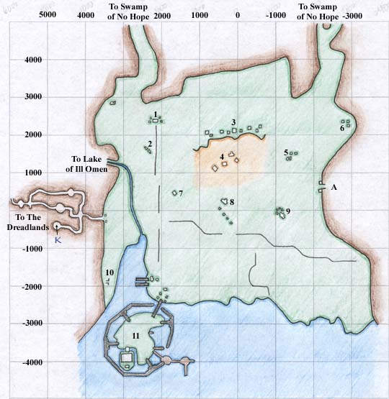

* 1. Empty Ruins
* 2. Empty Camp
* 3. Ruins
* 4. "Leech Field" - Ruins with leeches
* 5. Drolvarg Camp
* 6. Forest Giant Camp
* 7. Empty Ruins
* 8. Empty Ruins
* 9. Drolvarg Ruins and Camp
* 10. Underground Tunnel to Building 4 on Firiona Vie Docks
* 11. Firiona Vie Docks
* A. To Drolvarg Underground

**Frontier Mountains**

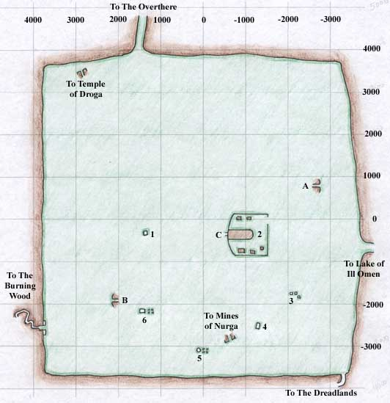

**Frontier Mountains**

* 1. Iksar Ruins with Sarnaks
* 2. Mountain Giant Fortress
* 3. Iksar Guardian Statues
* 4. Ruins with Goblins
* 5. Tower with Goblins
* 6. Empty Ruins, Bind Spot
* A. Entrance to Burynai Mines
* B. Entrance to Burynai Mines
* C. Entrance to Mountain Giant Mines
* Levant location: -633.00, -4286.00, 118.78 (near zoneline to Lake of Ill Omen)
* Note there is another Sarnak Ruins at approx +2000, -1800 on the map above.
* The tunnel to Dreadlands is at approximately -3668, -3327
* The entrance to Droga is at 3400, 2800/

**Lake of Ill Women**

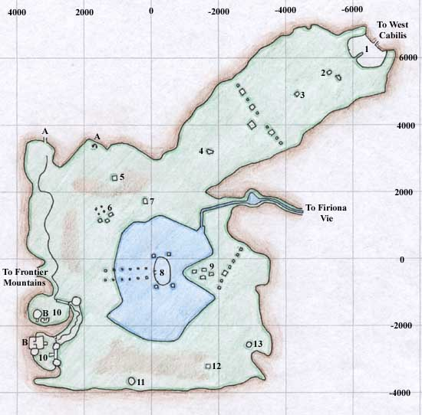

**Firiona Vie**

* 1. Cabilis Outpost Ruins - Merchants selling Patch Hide Armor, Newbie Weapons, Survival Gear, and Food Items
* 2. Goblin Hunter Outpost
* 3. Haunted Ruins
* 4. Hut with outcast Iksar
* 5. Empty Hut
* 6. Goblin Ruins
* 7. Tower with Explorers
* 8. Sunken Temple of Veksar
* 9. Goblin Ruins
* 10. Sarnak Fortress
* 11. Goblin-Infested Tower
* 12. Haunted Ruins
* 13. "[The Windmill](https://wiki.project1999.com/The_Windmill)" - Tower with [Professor Akabao](https://wiki.project1999.com/Professor_Akabao) and Merchant who sells [Poison](https://wiki.project1999.com/Skill_Make_Poison) Supplies
* A. Tunnels leading to the Goblin Mines that eventually lead to [Warsliks Woods](https://wiki.project1999.com/Warsliks_Woods" \o "Warsliks Woods)
* B. Tunnels leading to interior of Sarnak Fortress
* C. Astral Projection (-1913, -952) Near water, between 9 and 12 on the map. (Monk Epic NPC)
* Zone line to Frontier Mountains is located at -400, 3300

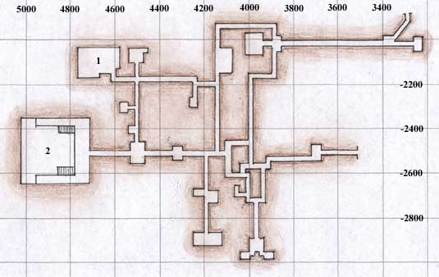

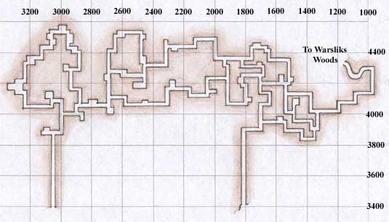

**Fortress/Goblin Fortress**

* 1. Weaponsmith Ko'Zirr and Imperial Escorts
* 2. Chancellor Di'Zok's Hall with [Chancellor of Di`Zok](https://wiki.project1999.com/Chancellor_of_Di%60Zok) who drops [Jade Chokidai Prod](https://wiki.project1999.com/Jade_Chokidai_Prod)

**Swamp of No Hope**

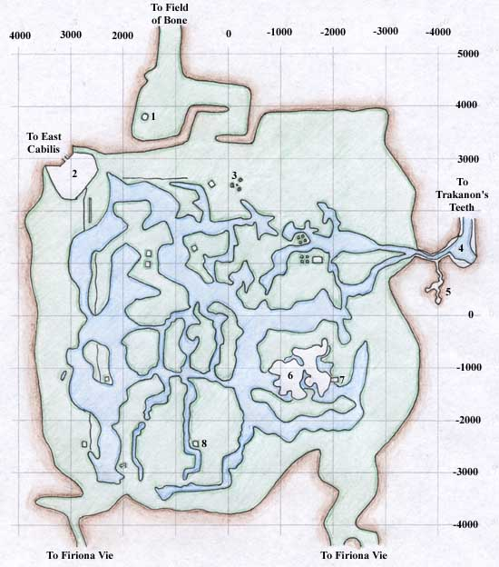

* 1. Ruined Tower - Contains [Ssessthrass](https://wiki.project1999.com/Ssessthrass" \o "Ssessthrass) for [Necromancer](https://wiki.project1999.com/Necromancer) epic
* 2. Cabilis Outpost Ruins - Merchants selling Patch Hide Armor, Newbie Weapons, Survival Gear, and Food Items
* 3. Outcast Iksar Camp
* 4. Outcast Iksar Hideout
* 5. Froglok Temple (Dugroz spawns nearby)
* 6. "Frogtown" - Froglok Village
* 7. "The Ramp" - only entrance to Froglok Village
* 8. Haunted Ruins

**Frontier Mountains**



**Frontier Mountains**

* 1. Iksar Ruins with Sarnaks
* 2. Mountain Giant Fortress
* 3. Iksar Guardian Statues
* 4. Ruins with Goblins
* 5. Tower with Goblins
* 6. Empty Ruins, Bind Spot
* A. Entrance to Burynai Mines
* B. Entrance to Burynai Mines
* C. Entrance to Mountain Giant Mines
* Levant location: -633.00, -4286.00, 118.78 (near zoneline to Lake of Ill Omen)
* Note there is another Sarnak Ruins at approx +2000, -1800 on the map above.
* The tunnel to Dreadlands is at approximately -3668, -3327
* The entrance to Droga is at 3400, 2800/